Big Data Program – 05

Name : Vishal Kumar H K

Usn : 1NT19IS189

HIVE INSTALLATION

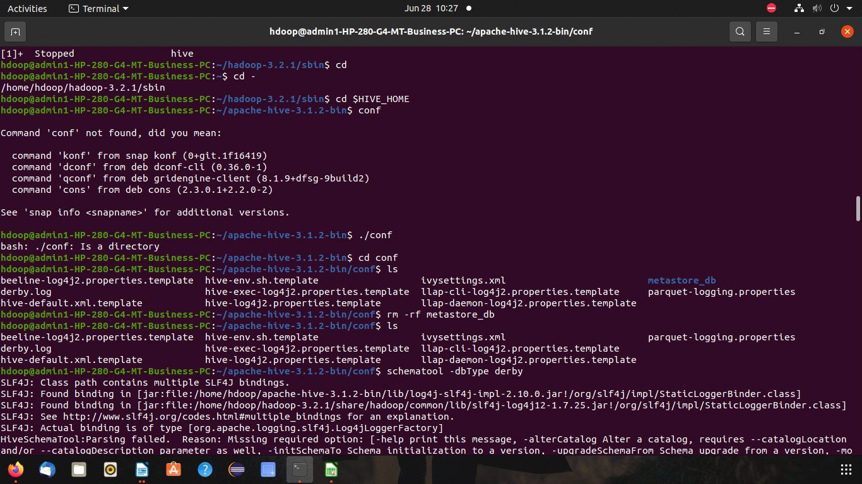

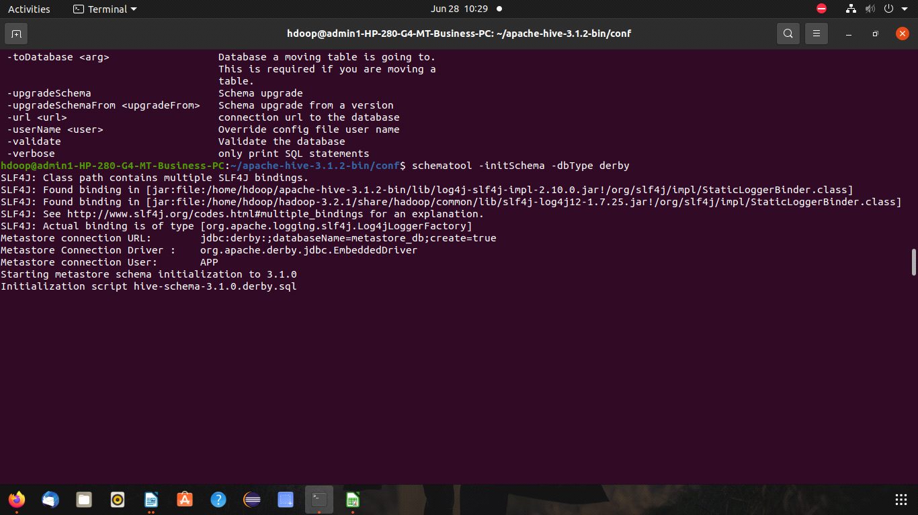

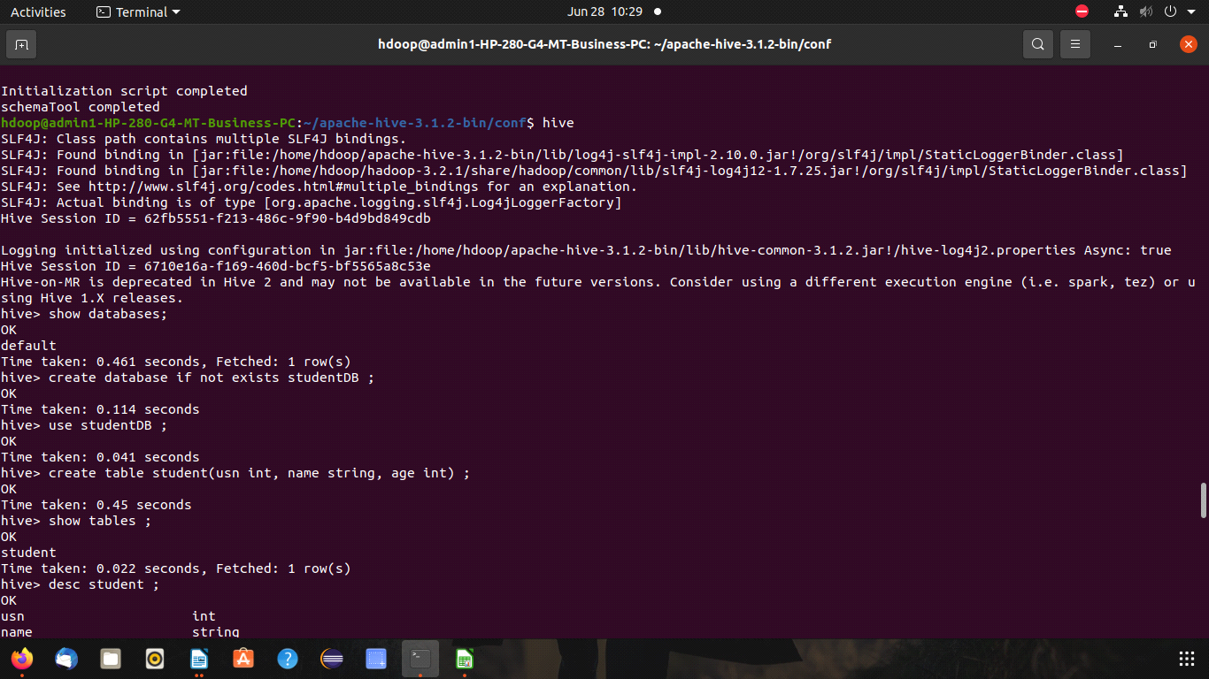

show databases;

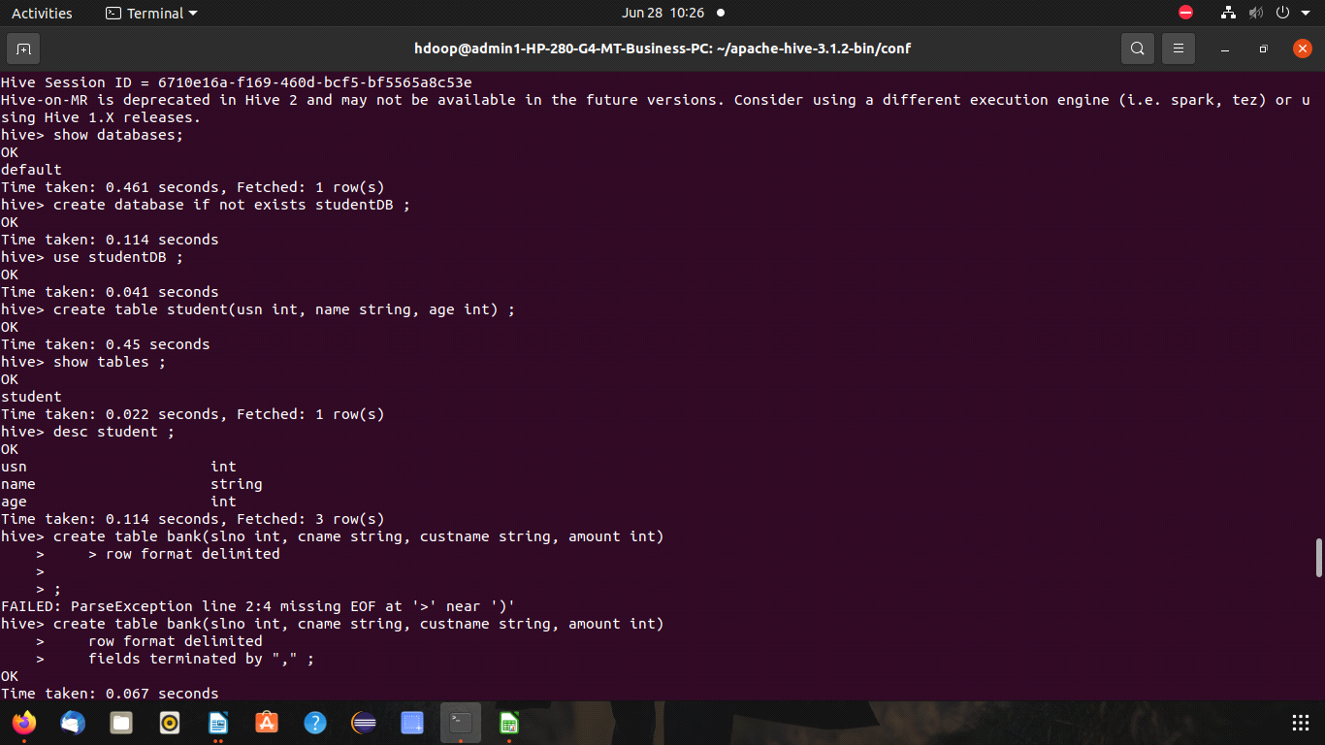

create database if not exists studentDB ;

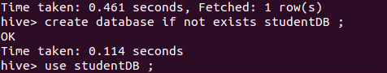

use studentDB ;



create table student(usn int, name string, age int) ;

show tables ;

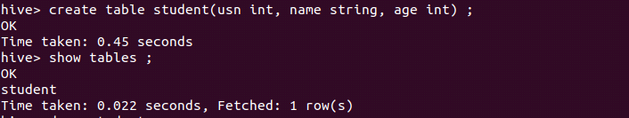

desc student ;

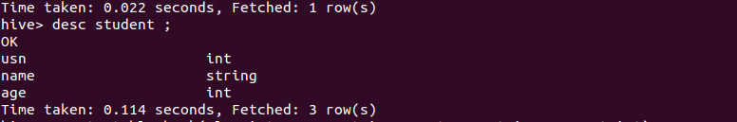

create table bank(slno int, cname string, custname string, amount int)

row format delimited

fields terminated by "," ;

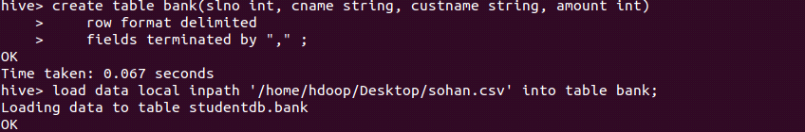

load data local inpath '/home/hdoop/Desktop/sohan.csv' into table bank;

select \* from bank;

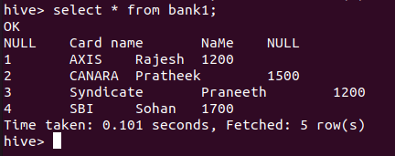

select max(Amount) from bank;

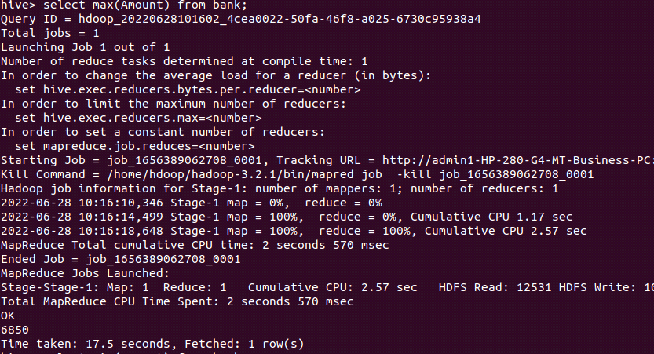

select min(Amount) from bank;

select avg(Amount) from bank;

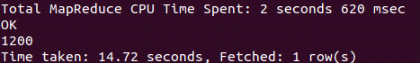

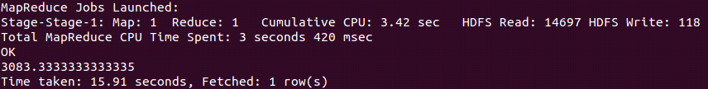

select count(\*) from bank;

